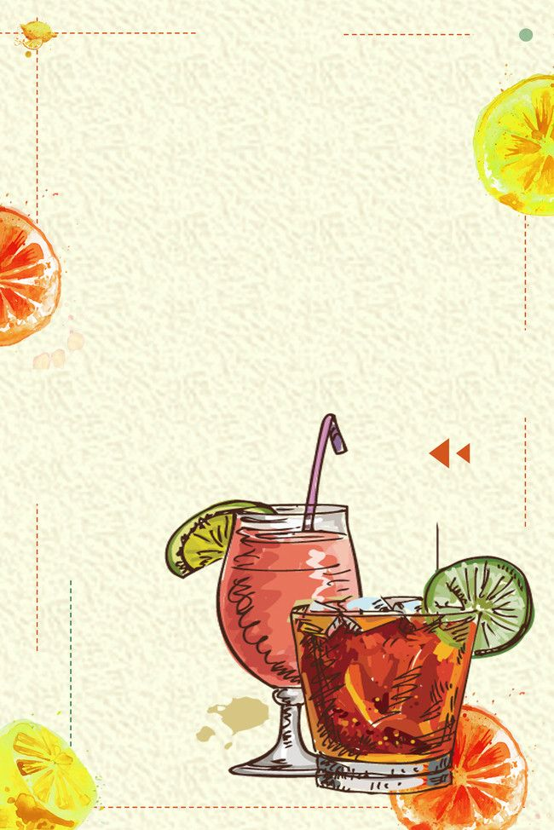
JOIN US FOR A
Christmas
PARTY
25
United States
1524 Nichols Ln Forest Gove, OR 97166
AT 8:30 PM
DECEMBER

